December 12, 2019

President Tom Slater opened the meeting of the Board of Trustees at 8:00 A.M. Trustee Steve Heringer offered an opening prayer.

The Trustees in attendance were Gary Merwin, Steve Barsoom, Jeff Merwin, and Steve Heringer. Also in attendance is Mark Wilson, and Secretary - Bookkeeper Vanessa Schmoker.

The agenda was approved as presented. (M- Heringer S- J. Merwin) Unanimous.

The minutes of the November 4, 2019 meeting were approved as presented. (M- Barsoom S- G. Merwin) Unanimous.

President Slater highlighted the financials for the month of November. President Slater reviews the check register and clarifies the checks written to CDTFA (California Department of Tax and Fee Administration, formerly Board of Equalization) which is payment for the District’s water licenses.

RESOLUTION 2019-12-12-1 to approve expenditures of $168532.04 for the operation and maintenance of said District, for the month of November as set forth in the Revolving Fund with proceeds from borrowing from the note at Bank of Stockton, California, at a balance of $0 be paid and the same are hereby unanimously ratified, approved and confirmed. (M- Heringer S- J. Merwin) Unanimous.

President Slater updates the Board on Assessment 3 Call 23. At the time of the meeting, the District has received 57% of the total assessment, leaving $387,499.35 still outstanding.

President Slater reviews Phase 1 progress of the Elk Slough project feasibility study. Fish monitoring is the next step. Fish, predators, food, etc. will be monitored 3 days a week through July. In addition to Elk Slough, data for Steamboat and Sutter Slough will also be documented. Funds for the Elk Slough project should start to come in by January, approximately $220,000 has been allocated for the fish study.

President Slater updates the Board on the meter install. The District has applied for another extension as the meters still have not been properly working or certified. As the District has been actively attempting to comply, there is no reason to believe the extension won’t be granted. The most recent solution the technician has tried seems to be working better with more consistent readings, however the extension would grant the District another year to complete the install and get everything certified.

President Slater presents the Manager’s Report to the Board.

President Slater reviews the budget for the four state funded programs the District is participating in. MBK is working on the 5-year plan, FMAP-LOI/SWIF, and FSRP-Sutter Slough, and has completed the Subventions application for 2018-19. The District has not yet received funds for FSRP-Sutter Slough as there are more studies required to move forward.

The fall levee inspection is complete, the District is still waiting for the grade. The Sacramento River and Sutter Slough repairs are preventing the District from being eligible for an A grade, but President Slater is hopeful for a passing grade, same as last year.

In a RD 765 consolidation update President Slater relays communications from their attorney, Pat Markham, that they insist they are still interested. Pat Markham had deferred further talks with President Slater until December 9 as the RD 765 Board was supposed to meet to discuss things further. As of the morning of this meeting, President Slater has not heard back.

President Slater informs the Board that District employee Justin Dorris gave the District his notice of resignation as he was accepted to the Sacramento Sherriff’s academy. His last day was November 29th. President Slater, at this time, would like to consider offering part-time employee, Paul Fenocchio, a full-time position. While Paul is not an equipment operator like Justin was, his hard work on levee maintenance has been incredible in contributing to a passing inspection grade, has been helpful in the shop mechanically as well, and almost all of his hours have been claimed and reimbursed through Subventions. The Board discusses whether or not to put him on a 50-hour work week schedule like the current full-time employees or a 40-hour work week, ultimately deciding to keep his current pay rate of $14.00/hour at 40 hours a week. His full-time status would be effective immediately. (M- Heringer S- Barsoom) Unanimous.

President Slater reviews the progress of the new trash screen install. The screen itself cost $2,500.00. The install will need to be done by divers at an additional cost, but the process has been slightly delayed.

The spraying of Winchester Lake has been completed, that bill will come in and be paid by the end of December.

President Slater addressed the irrigation levels in the District. Multiple times throughout the year different landowners have different needs for water. Most of the gates within the District have been removed as they age and rust, but the Board believes investigating the cost to replace certain gates throughout the District would be prudent in order to have more control over fluctuating water levels and needs. The process is not urgent but is worth investigating.

President Slater informs the Board that one of the old excavators will be going to auction in January. There is a slight concern over low bids as there is no minimum requirements at the auction, however previous sales with similar equipment were reviewed and President Slater is confident enough to chance the action. President Slater just wanted to prepare the Board in case there is a lower bid/sale price than expected.

At 10:00 am the meeting went into closed session to review employee medical hbenefits for the 2020 year. The Board discussed the rising cost of medical insurance and possible steps to be taken to allow employees to keep their current plans. The Board voted to have employees contribute 25% of the cost of their dependents’ expense for the year 2020, and to revisit in 2021 for a possible increase. (M- Heringer S- Barsoom) Unanimous.

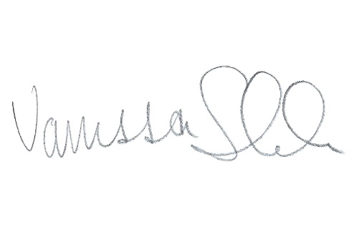
The next Board meeting is scheduled for Thursday January 9, 2020. The meeting was adjourned at 11:40 am.

__________________
Vanessa Schmoker – Secretary

