July 11, 2019

President Tom Slater opened the meeting of the Board of Trustees at 8:00 A.M. Trustee Steve Heringer offered an opening prayer.

The Trustees in attendance were Gary Merwin, Jeff Merwin, Steve Barsoom, and Steve Heringer. Also in attendance was Gil Cosio with MBK, LAND attorney Osha Meserve and Secretary - Bookkeeper Vanessa Schmoker.

The agenda was approved as presented. (M- G. Merwin S- Barsoom) Unanimous.

The minutes of the June 12, 2019 meeting were approved as presented. (M- Heringer S- Barsoom) Unanimous.

President Slater highlighted the financials for the month of June. President Slater reviews progress made by the SAC CCC on tree trimming, the MBK bill, and the Grow West bill.

RESOLUTION 2019-7-11-1 to approve expenditures of $74,847.86 for the operation and maintenance of said District, for the month of June as set forth in the Revolving Fund with proceeds from borrowing from the note at Bank of Stockton, California, at a balance of $0 be paid and the same are hereby unanimously ratified, approved and confirmed. (M- Heringer S- Barsoom) Unanimous.

Gilbert Cosio with MBK begins the Engineer’s Report with a quick reminder that the 2018-19 fiscal year ended June 30th. Subventions claims are due before November 1, but encourages the District to submit reimbursements as soon as possible. Gil updates the Board that the Sacramento River erosion repair has been delayed until 2020 due to permitting issues. MBK submitted the application for the 2018-19 FMAP funds and the District should expect the first $40,000.00 within 6 weeks. MBK is working on the 2019-20 application for an additional $40,000.00. These funds will be used to prepare the LOI/SWIF, which MBK is hopeful will be complete by spring 2020. Gil revisits the Elk Slough project, which the Delta Conservancy decided in May not to fund. The Conservancy has agreed to gather multiple agency and fishery experts to discuss the benefits of the project. If the group decides there is enough benefit to fisheries and flood control the Conservancy will commit to fund project after all. Gil presents a Labor Compliance Program (LCP) report that needed to be signed in order to comply with the Prop 84 funding to the Subventions program. While Subventions is sometimes funded by Prop 1E and sometimes Prop 84, MBK makes sure to submit the LCP annually to be prepared for when Prop 84 funds are used. MBK has finished processing the LiDAR data and will start presenting information to the District at upcoming meetings. The LiDAR data will be used to prepare the 5-year plan. Lastly, Gil and President Slater make sure that the District knows to keep all of the funding for the LOI/SWIF, 5-year Plan, and Subventions, separate from the general fund and to make sure that it’s expenses are being properly coded in the system.

The Board welcomes LAND attorney Osha Meserve to make her LAND update presentation. Osha begins with a brief history of how LAND started back in 2011. From 2008-2011, Reclamation District was responsible for the entire bill for Osha to begin the fight against the tunnels, at the time called the Bay-Delta Conservation Plan. LAND began in order to spread the cost between multiple local water agencies in the North Delta. Currently, DWR has announced that it has rescinded the current twin tunnel plan after a 10 year fight. While that is great news, DWR, the finance JPA, and the construction JPA are seemingly moving forward with a single tunnel project, as evident from the JPA board packet that shows a budget of over $100 million to work toward the single tunnel project. There is also evidence of DWR doing investigatory drilling along the original tunnel route, which Sacramento County has been able to temporary stop with a restraining order as DWR did not get the permits for the geotechnical work. The new EIR for the single tunnel project, that would be required to move forward, would take approximately 3 years and will show the design for the new project including proposed diversion points in the North Delta. Osha updates the Board on the Delta Protection Commission’s (DPC) plan to update its Resource Management Plan (RMP). The DPC is proposing to delete many of its current policies in the RMP that protects landowners and districts from incompatible restoration projects. Osha will be working with Melinda Terry (Central Valley Flood Control Association) and the Farm Bureau to insist that the DPC maintain the current protective policies. Osha distributes the North Delta Arc map to the Board with an explanation of the Voluntary Agreements process for proposed projects within the arc. These projects are being followed closely by Osha in order to monitor the modeling of negative water quality effects in the Delta. To summarize her presentation to the Board, Osha maintains that stopping any new tunnel project is her main focus for LAND, however smaller projects are happening that she feels could affect the District and she will continue to work on those as well. Osha excused herself and was thanked for her time and hard work.

In a brief assessment update, two assessment liens have been filed at the Yolo County recorders office for the final two delinquencies. This will allow the District to move forward with placing the outstanding amounts on the landowners’ property tax bill. This process will be complete in early August. Between all but two assessments being paid, and the subventions check for the 2017-18 claim being received, the balance in the checking account at Bank of Stockton is approximately $600,000.00.

President Slater makes a brief Yolo GSA update. The District, as well as most neighboring RD’s, have paid the Yolo GSA bill. It’s been determined that those who left the North Delta GSA to join Yolo GSA do not owe dues to North Delta GSA for the past 2 years.

Between the presentation from Osha regarding LAND, and a little bit of confusion regarding further LAND funding, the Board revisits the issue. Clarification for the funding decision resulted in the following motion:

Reclamation District 999 will continue to fund LAND at $1/acre through August 2019. At the September 2019 Reclamation District 999 meeting, and every four months after, the Board will vote as to whether or not funding will continue for the following four months and at what rate. (M- Heringer S- Barsoom) Unanimous.

Lastly, Jennifer Kirtlan asked President Slater if the Board would consider abandoning an easement on Alexander Ct. President Slater informed her that it is not common for the District to abandon easements, but he would need more information before asking the Board to vote. The discussion was tabled and will be revisited at a later meeting.

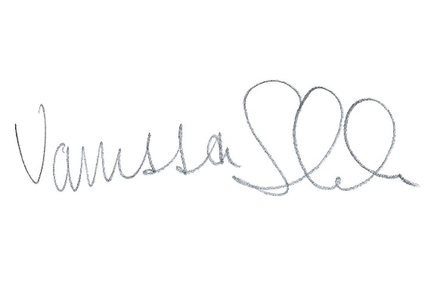
The next Board meeting is scheduled for Thursday August 8, 2019. The meeting was adjourned at 11:50.

___________________
Vanessa Schmoker – Secretary

